**Creating a SQL Database on Azure**

**Step 1:** First of all open your azure portal i.e., [portal.azure.com](https://portal.azure.com). 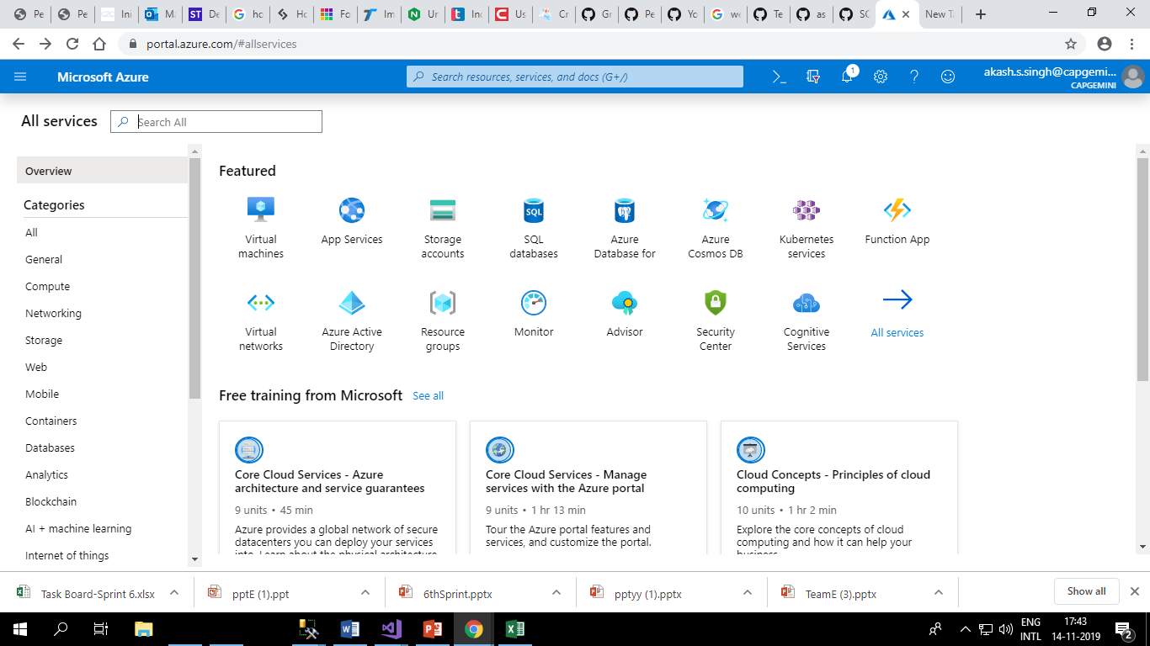

**Step 2:** Next, select SQL databases in azure services.

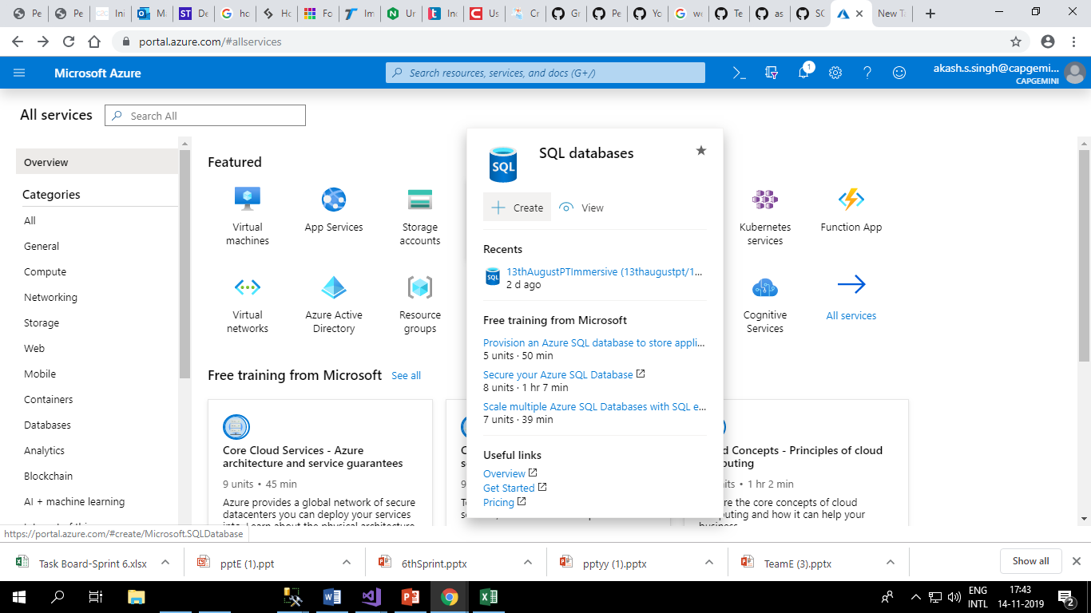

**Step 3:** Select the subscription and resource group.

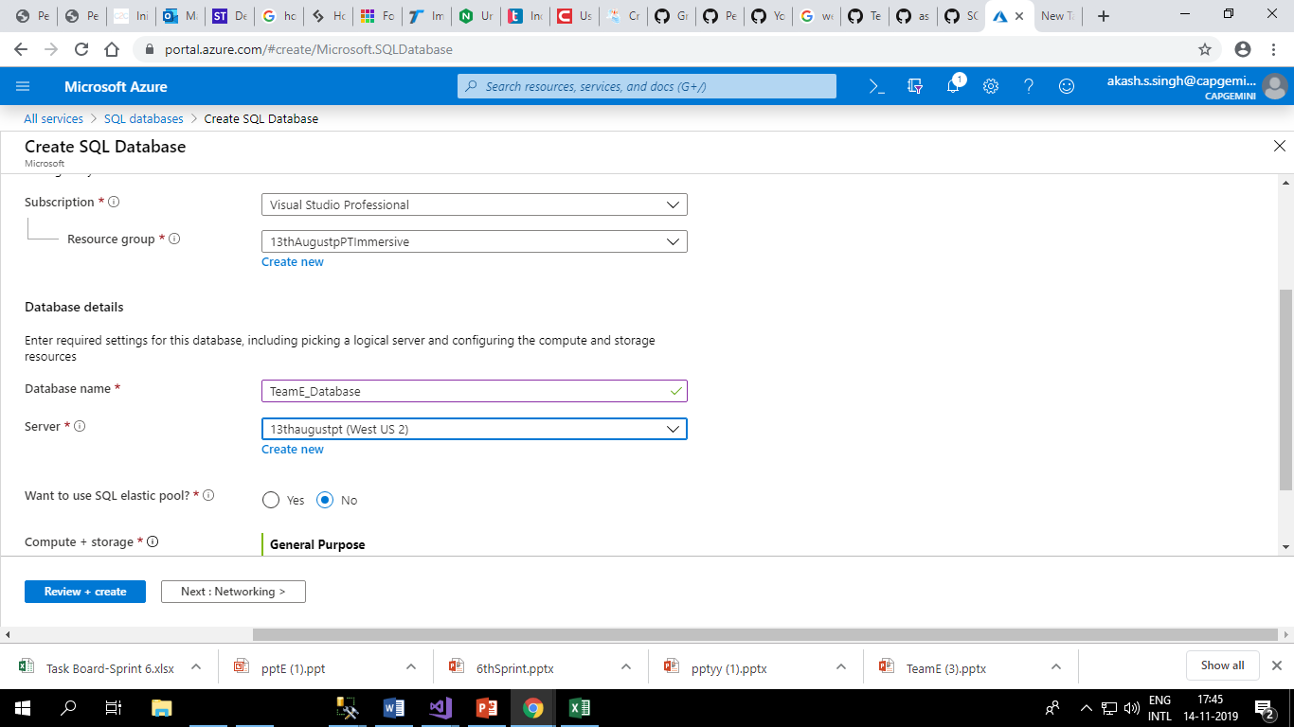

**Step 4:** Select configure database below

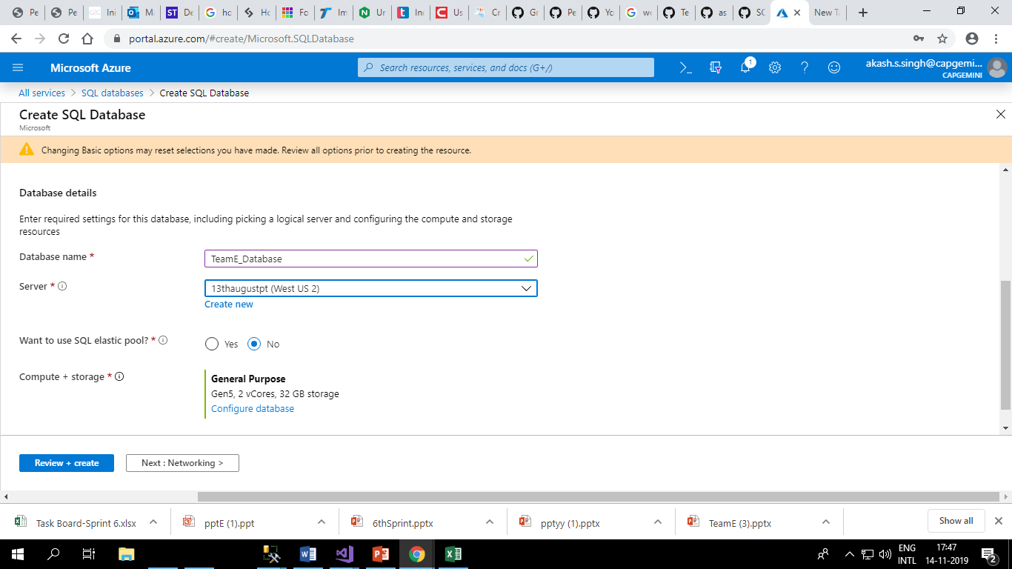

**Step 5:** Select configuration and click on Apply

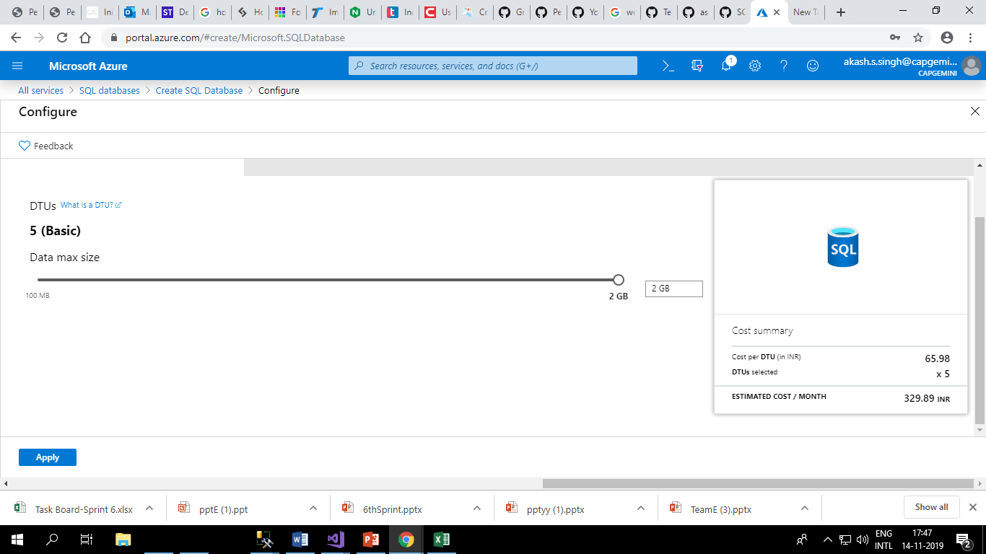

**Step 6:** Click on Next: Networking



**Step 7:** Click on Next: Additional settings

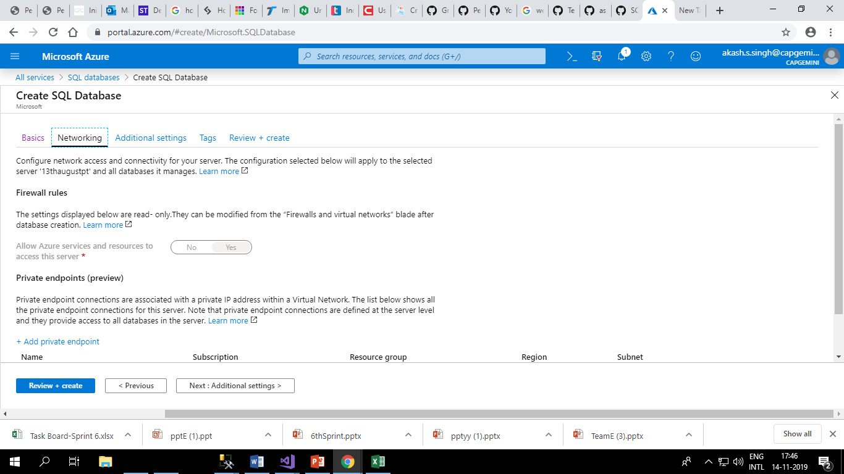

**Step 8:** Click on Next: Tags

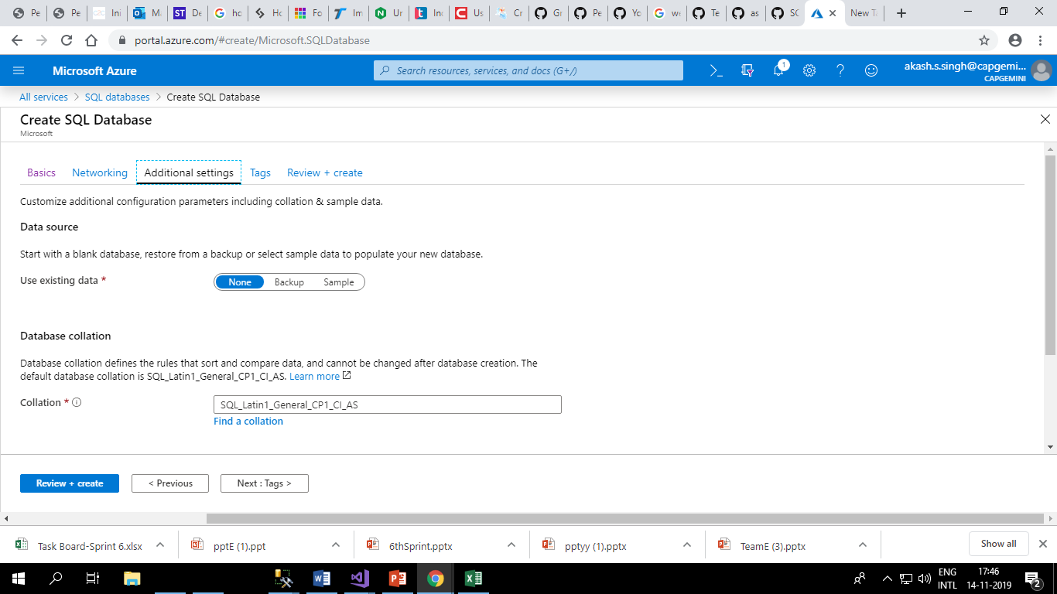

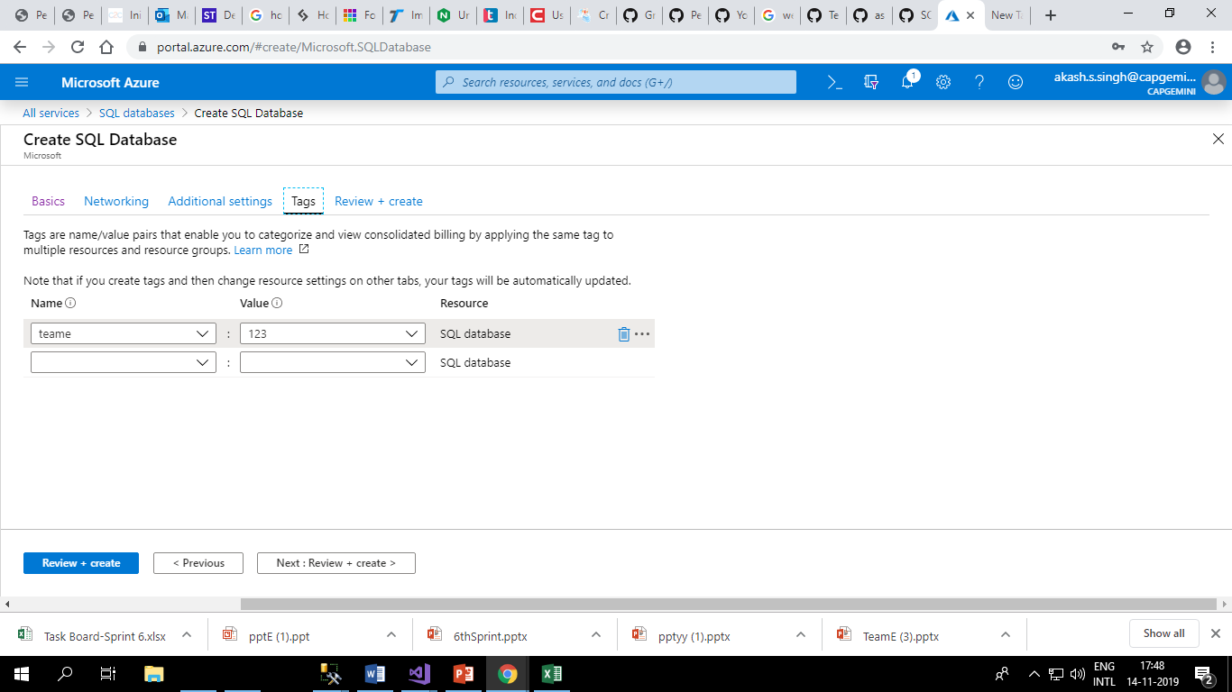

**Step 8:** Enter name and value and then **c**lick on Next: Review + Create



**Step 9:** Click on Create.

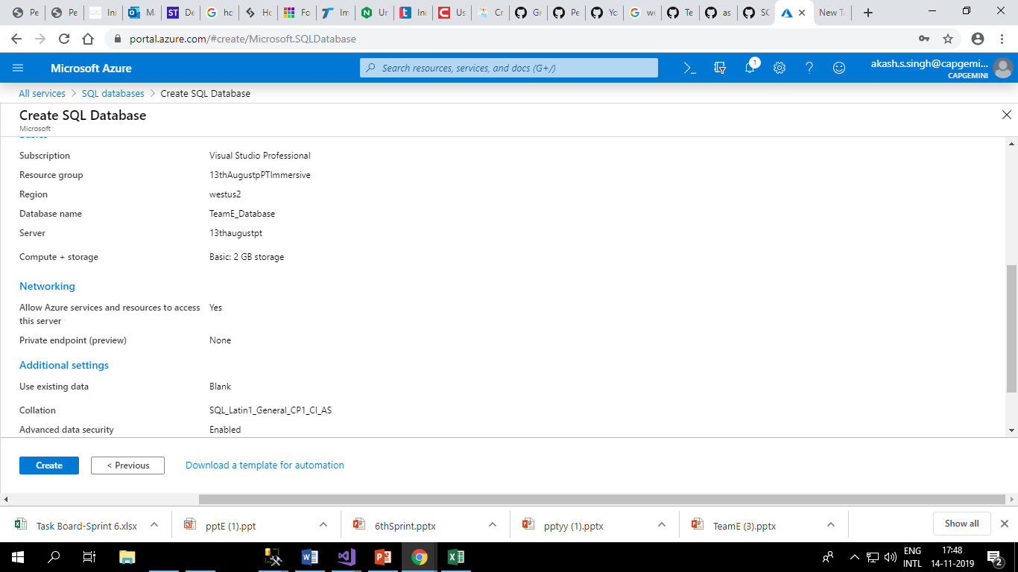

Wail for some time till the deployment gets completed.

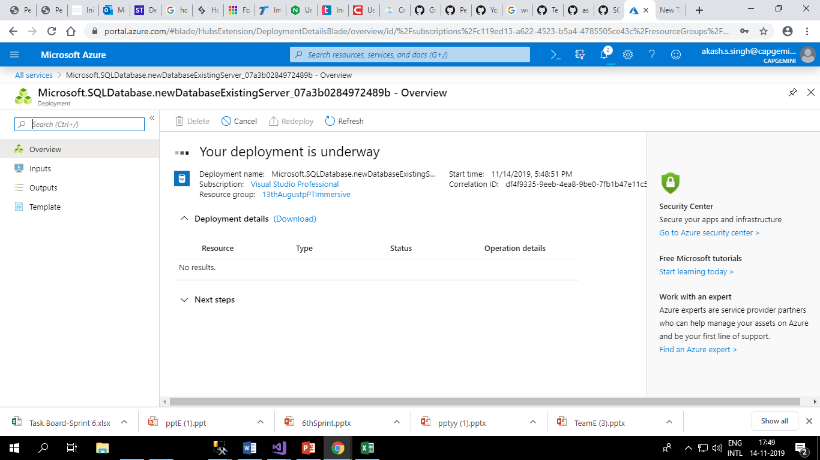

Your deployment is complete.

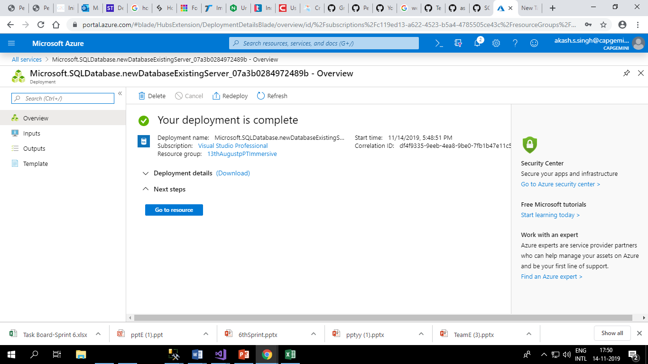

Click on Go to Resource. The details about the database will be displayed.

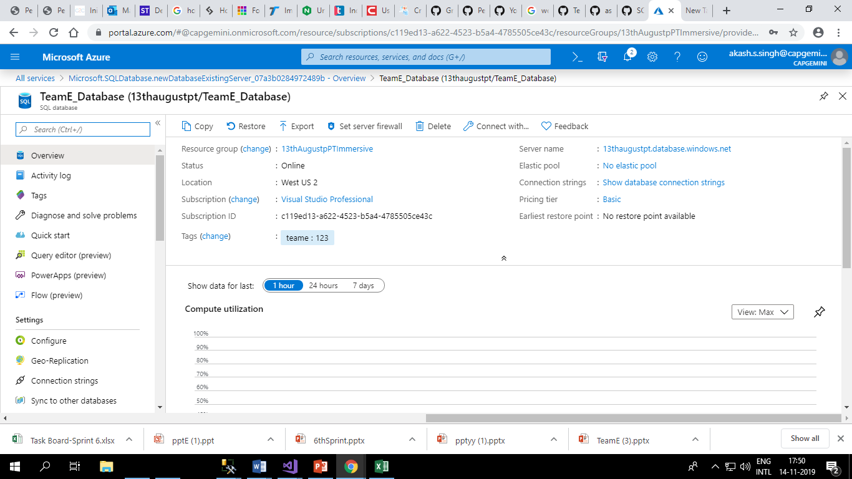

Click on connection strings and copy the connection string. This connection string will have to be entered in the webconfig file in the visual studio application.

